BANK LOAN REPORT QUERY DOCUMENT
- BANK LOAN REPORT | SUMMARY

KPI’S

Total Loan Applications
SELECT COUNT(id) Total_Loan_Applications FROM bank_loan_data
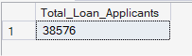
MTD Loan Applications
SELECT COUNT(id) Month_To_Date_Applications FROM bank_loan_data
WHERE MONTH(issue_date)=12
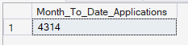
PMTD Loan Applications
SELECT COUNT(id) Previous_MTD_Applications FROM bank_loan_data
WHERE MONTH(issue_date)=11
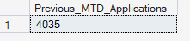

Total Funded Amount
SELECT SUM(loan_amount) Total_Funded_Amount FROM bank_loan_data
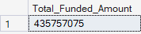
MTD Total Funded Amount
SELECT SUM(loan_amount) MTD_Total_Funded_Amount FROM bank_loan_data
WHERE MONTH(issue_date)=12
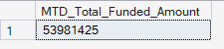

PMTD Total Funded Amount
SELECT SUM(loan_amount) MTD_Total_Funded_Amount FROM bank_loan_data
WHERE MONTH(issue_date)=12
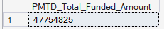

Total Amount Received
SELECT SUM(total_payment) Total_Amount_Received FROM bank_loan_data
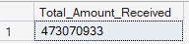
MTD Total Amount Received
SELECT SUM(total_payment) MTD_Total_Amount_Received FROM bank_loan_data
WHERE MONTH(issue_date)=12
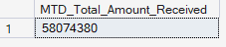
PMTD Total Amount Received
SELECT SUM(total_payment) PMTD_Total_Amount_Received FROM bank_loan_data
WHERE MONTH(issue_date)=11
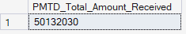

Avg Interest Rate
SELECT ROUND(AVG(int_rate)*100,2) Avg_Interest_Rate FROM bank_loan_data
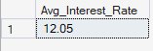

MTD Avg Interest Rate
SELECT ROUND(AVG(int_rate)*100,2) MTD_Avg_Interest_Rate FROM bank_loan_data
WHERE MONTH(issue_date)=12
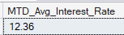
PMTD Avg Interest Rate
SELECT ROUND(AVG(int_rate)*100,2) PMTD_Avg_Interest_Rate FROM bank_loan_data
WHERE MONTH(issue_date)=11

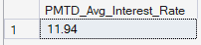

Avg DTI
SELECT ROUND(AVG(dti)*100,2) Avg_Dti FROM bank_loan_data
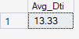
MTD Avg DTI
SELECT ROUND(AVG(dti)*100,2) MTD_Avg_Dti FROM bank_loan_data
WHERE MONTH(issue_date)=12
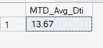
PMTD Avg DTI
SELECT ROUND(AVG(dti)*100,2) PMTD_Avg_Dti FROM bank_loan_data
WHERE MONTH(issue_date)=11
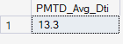

GOOD LOAN ISSUED

Good Loan Percentage
SELECT
(COUNT(CASE WHEN loan_status= 'Fully Paid' OR loan_status='Current' THEN id END)*100)
/
COUNT(id) AS Good_loan_Percentage
FROM bank_loan_data
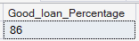
Good Loan Applications
SELECT COUNT(id) Good_Loan_Application FROM bank_loan_data
WHERE loan_status='Fully Paid' OR loan_status='Current'
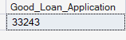
Good Loan Funded Amount
SELECT SUM(loan_amount) Good_Loan_Funded_Amount FROM bank_loan_data
WHERE loan_status='Fully Paid' OR loan_status='Current'
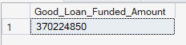
Good Loan Received Amount
SELECT SUM(total_payment) Good_Loan_Amount_received FROM bank_loan_data
WHERE loan_status='Fully Paid' OR loan_status='Current'
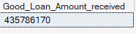

BAD LOAN ISSUED

Bad Loan Percentage
SELECT
(COUNT(CASE WHEN loan_status= 'Charged off' THEN id END)*100.0)
/
COUNT(id) AS Bad_loan_Percentage
FROM bank_loan_data
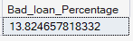

Bad Loan Applications
SELECT COUNT(id) Bad_Loan_Application FROM bank_loan_data
WHERE loan_status='Charged off'
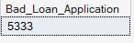
Bad loan funded Amount
SELECT SUM(loan_amount) Bad_Loan_Funded_Amount FROM bank_loan_data
WHERE loan_status='Charged off'
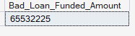
Bad Loan Amount Received

SELECT SUM(total_payment) Bad_Loan_Amount_received FROM bank_loan_data
WHERE loan_status='Charged off'
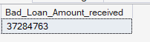

LOAN STATUS
SELECT
loan_status,
COUNT(id) AS Total_Loan_Applications,
SUM(total_payment) AS Total_Payment_Received,
SUM(loan_amount) AS Total_Funded_Amount,
AVG(int_rate *100) AS Interest_Rate,
AVG(dti*100) AS DTI
FROM bank_loan_data
GROUP BY loan_status
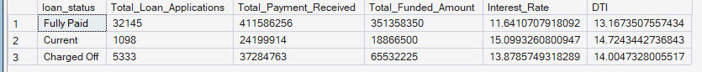

SELECT loan_status,SUM(total_payment) AS MTD_Total_Amount_Received,
SUM(loan_amount) AS MTD_Total_Funded_Amount
FROM bank_loan_data
WHERE MONTH(issue_date)=12
GROUP BY loan_status
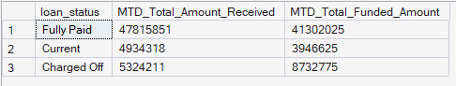

- BANK LOAN REPORT | OVERVIEW
MONTH
SELECT
MONTH(issue_date) AS Month_Munber,
DATENAME(MONTH, issue_date) AS Month_name,
COUNT(id) AS Total_Loan_Applications,
SUM(loan_amount) AS Total_Funded_Amount,
SUM(total_payment) AS Total_Amount_Received
FROM bank_loan_data
GROUP BY MONTH(issue_date), DATENAME(MONTH, issue_date)
ORDER BY MONTH(issue_date)

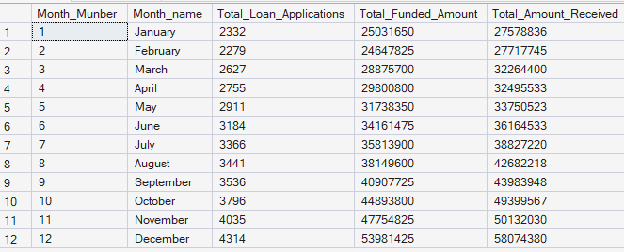

STATE
SELECT
address_state AS State,
COUNT(id) AS Total_Loan_Applications,
SUM(loan_amount) AS Total_Funded_Amount,
SUM(total_payment) AS Total_Amount_Received
FROM bank_loan_data
GROUP BY address_state
ORDER BY address_state
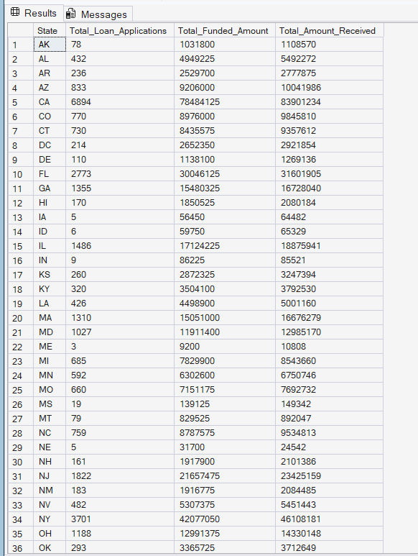

TERM
SELECT
term AS Term,
COUNT(id) AS Total_Loan_Applications,
SUM(loan_amount) AS Total_Funded_Amount,
SUM(total_payment) AS Total_Amount_Received
FROM bank_loan_data
GROUP BY term
ORDER BY term
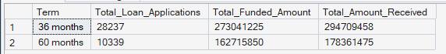

EMPLOYEE LENGTH
SELECT
emp_length AS Employee_Length,
COUNT(id) AS Total_Loan_Applications,
SUM(loan_amount) AS Total_Funded_Amount,
SUM(total_payment) AS Total_Amount_Received
FROM bank_loan_data
GROUP BY emp_length
ORDER BY emp_length
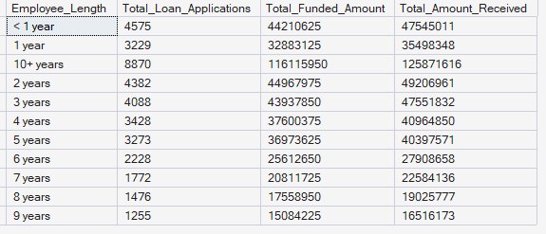

PURPOSE
SELECT
purpose AS PURPOSE,
COUNT(id) AS Total_Loan_Applications,
SUM(loan_amount) AS Total_Funded_Amount,
SUM(total_payment) AS Total_Amount_Received
FROM bank_loan_data
GROUP BY purpose
ORDER BY purpose
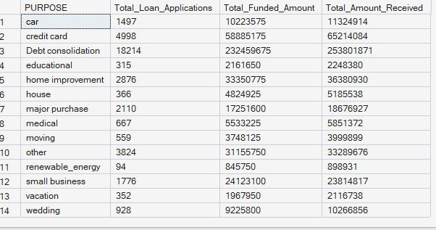

HOME OWNERSHIP
SELECT
home_ownership AS Home_Ownership,
COUNT(id) AS Total_Loan_Applications,
SUM(loan_amount) AS Total_Funded_Amount,
SUM(total_payment) AS Total_Amount_Received
FROM bank_loan_data
GROUP BY home_ownership
ORDER BY home_ownership
